Exercise session 2
Problem 1 [How to supervise the supervision]
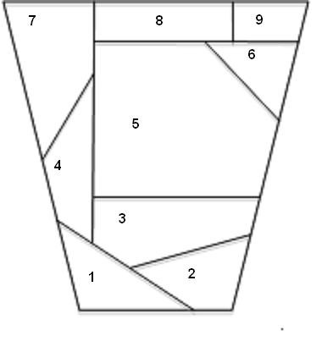
In order to make the exam proceed as smooth as possible, the exam hall is divided into segments as illustrated in the picture. Each sector has to be supervised by at least one TA or two TA’s from the neighboring sectors. How many TA’s does it take to successfully supervise the exam hall?
- Formulate an integer program.
- Solve it using Solver for Excel.
- Suppose that instead of two there has to be at least three TA’s to supervise the neighboring sector. What is the solution now?
Problem 2 [Fiver game]
Go to page: http://www.mazeworks.com/fiver/index.htm and play the game Fiver. The goal is to switch the color of ALL squares to black. When you click on a given square you switch the color of this square and all neighboring squares (having at least one common edge) (if a given square is black it becomes white and if it is white it becomes black). For the 5 by 5 board formulate an integer problem trying to minimize the number of clicks and solve it using Excel Solver.
Problem 3 [Cutting sticks to play Moelkky]
Moelkky is a popular Finnish game. One set to play Moelkky consists of 12 wooden sticks of length 15 cm each and one wooden stick of length 23 cm. All sticks have the same diameter of 5.5 cm. You received an order to make 100 such sets. Design a plan to cut 1 meter long wooden stick with a given diameter between 0-20cm such that:
- you cut as few 1-meter sticks as possible
- the waste is minimized
- there are as many sets from 1000 1-meter sticks as possible

